* In the Hypothetical Machine the contents of memory was as shown. And PC contents is 300. Show the contents of memory and PC , AC , IR after execute three instructions (three fetch cycle and there execute cycle)

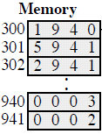

Q1

STEP 1

FETCHING

MEMORY

|  |
| --- |
| 1940 |
| 5941 |
| 2941 |

|  |
| --- |
| PC: 300 |
| AC: |
| IR:1940 |

300

301

302

|  |
| --- |
| 0003 |
| 0002 |

940

941

STEP 2

EXECUTION

MEMORY

|  |
| --- |
| 1940 |
| 5941 |
| 2941 |

|  |
| --- |
| PC:301 |
| AC:0003 |
| IR:1940 |

300

301

302

|  |
| --- |
| 0003 |
| 0002 |

940

941

STEP3

FETCHING

MEMORY

|  |
| --- |
| 1940 |
| 5941 |
| 2941 |

|  |
| --- |
| PC:302 |
| AC:0003 |
| IR:5941 |

300

301

302

|  |
| --- |
| 0003 |
| 0002 |

940

941

STEP4

EXECUTION

MEMORY

|  |
| --- |
| 1940 |
| 5941 |
| 2941 |

|  |
| --- |
| PC:302 |
| AC:0005 |
| IR:5941 |

300

301

302

|  |
| --- |
| 0003 |
| 0002 |

940

941

3+2=5

STEP5

FETCHING

MEMORY

|  |
| --- |
| 1940 |
| 5941 |
| 2941 |

|  |
| --- |
| PC:302 |
| AC:0005 |
| IR:2941 |

300

301

302

|  |
| --- |
| 0003 |
| 0002 |

940

941

STEP6

EXECUTION

MEMORY

|  |
| --- |
| 1940 |
| 5941 |
| 2941 |

|  |
| --- |
| PC:303 |
| AC:0005 |
| IR:2941 |

300

301

302

|  |
| --- |
| 0003 |
| 0005 |

940

941

* Show the contents of PC , AC and IR and memory after the execution of each instruction of the following program on the Hypothetical Machine:
* 300 LOAD 550
* 301 ADD 551
* 302 STORE 600
* Where the contents of memory at 550 is 3 and at 551 is 4.
* The following figure provide the main characteristics of Hypothetical Machine.

Q2 STEP1 FETCHING

|  |
| --- |
| 1550 |
| 5551 |
| 2600 |

|  |
| --- |
| PC:301 |
| AC:0003 |
| IR:1550 |

300

301

302

|  |
| --- |
| 0003 |
| 0004 |
|  |

550

551

600

STEP2 EXECUTION

MEMORY

|  |
| --- |
| 1550 |
| 5551 |
| 2600 |

|  |
| --- |
| PC:301 |
| AC:0003 |
| IR:5551 |

300

301

302

|  |
| --- |
| 0003 |
| 0004 |
|  |

550

551

600

STEP3 FETCHING

MEMORY

|  |
| --- |
| 1550 |
| 5551 |
| 2600 |

|  |
| --- |
| PC:301 |
| AC:0003 |
| IR:5551 |

300

301

302

|  |
| --- |
| 0003 |
| 0004 |
|  |

550

551

600

STEP4 EXECUTION

MEMORY

|  |
| --- |
| 1550 |
| 5551 |
| 2600 |

|  |
| --- |
| PC:302 |
| AC:0007 |
| IR:5551 |

300

301

302

|  |
| --- |
| 0003 |
| 0004 |
|  |

550

551

600

3+4=7

STEP5 FETCHING

MEMORY

|  |
| --- |
| 1550 |
| 5551 |
| 2600 |

|  |
| --- |
| PC:302 |
| AC:0007 |
| IR:2600 |

300

301

302

|  |
| --- |
| 0003 |
| 0004 |
|  |

550

551

600

STEP6 EXCUTION

MEMORY

|  |
| --- |
| 1550 |
| 5551 |
| 2600 |

|  |
| --- |
| PC:303 |
| AC:0007 |
| IR:2600 |

300

301

302

|  |
| --- |
| 0003 |
| 0004 |
| 0007 |

550

551

600

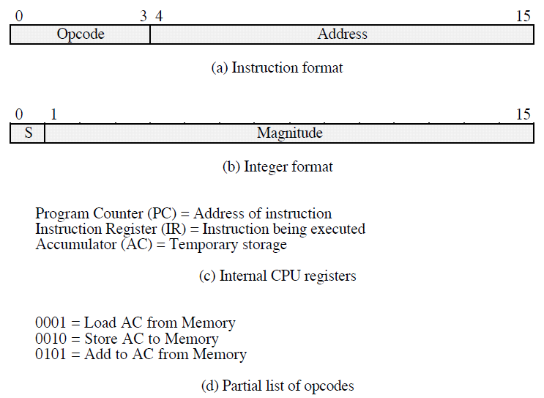

Q3:

MEMORY

|  |
| --- |
| 3005 |
| 5940 |
| 7006 |

300

301

302

AFTER EXECUTING THREE INSTRUCTIONS

DEVICE 5 : 0003

940 : 2

DEVICE 6 : 0005